Helpful Tips for New SCUSD Website

Navigation Terms
How your navigation works
Your navigation menu is based upon a vocabulary called Navigation Terms. You have the ability to add terms, rename terms, and reorder them. Keep in mind that most website designs plan for a specific number of links across the top of the page, so adding additional terms to the top level of your navigation may break the layout.
- Go to Manage Nav Terms on the Commands menu.
- To reorder the terms, grab the handle to the left of a term and drag it to its new location. Make sure to save the order (button at the bottom of the page) when you're done or your changes will be lost.
- To rename terms, click the Edit link to the right of the term, under the Operations column. Make the desired changes and click save.
- To add new sub-terms:
  - Click the Add term tab at the top of the Manage Nav Terms area
  - Give the term a name (keep in mind that this will display in the site navigation, including any drop down and sidebar menus)
IMPORTANT: When creating new terms, be sure to choose a parent for the term! If you don't choose a parent it will default to "root," which will make it appear at the top level in your navigation bar, as mentioned above.

The Commands Menu

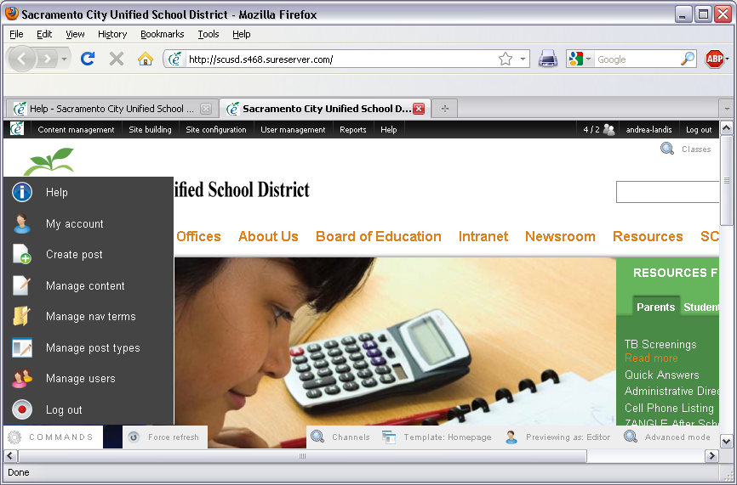
Once you're logged in you'll see a gray Commands button in the lower left corner of your screen. Hover over it and a menu will appear, giving you shortcuts to various things you can do within the site.
- Help. The link to the website help page.
- My account. The link to your website account page, where you can edit your user name, change your password, etc.
- Create post. Allows you to create new content.
- Manage Nav Terms. Takes you to the navigation term tree, where you can edit, add or reorder nav terms.
- Manage Post Types. Takes you to the post type term tree, where you can edit, add or reorder post types.
- Manage users. Takes you to a page where you can activate memberships, assign roles, edit users, etc.
- Log out. This button logs you out of the site altogether.

Understanding the Content section
You will be responsible for content for your department. Most of this information will reside on your department’s section although some of it may reside in other parts of the website.
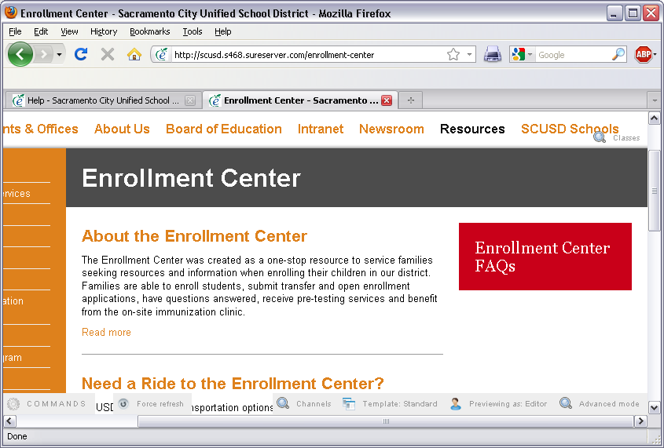
The editable parts of the content are divided into two sections.
Main Section or Center Channel
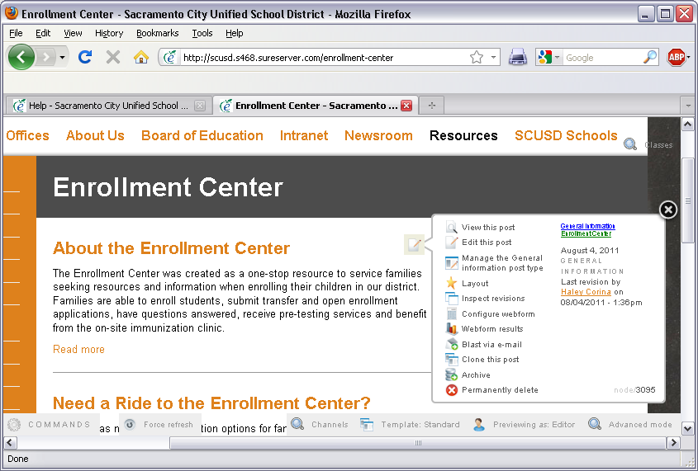
In the main section you will edit and create posts. If you hover over any post you will see a little notepad icon appear. When you click on it a menu of functions will appear. The one you will be using the most is the “edit this post” function.
Sidebar
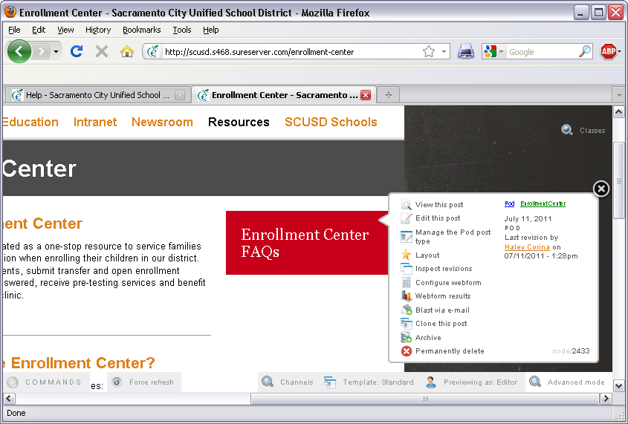
The sidebar posts are called pods and they function the same as other posts. You can edit them by clicking on the notepad icon that appears when you hover over it.

Working with Posts
Post Types
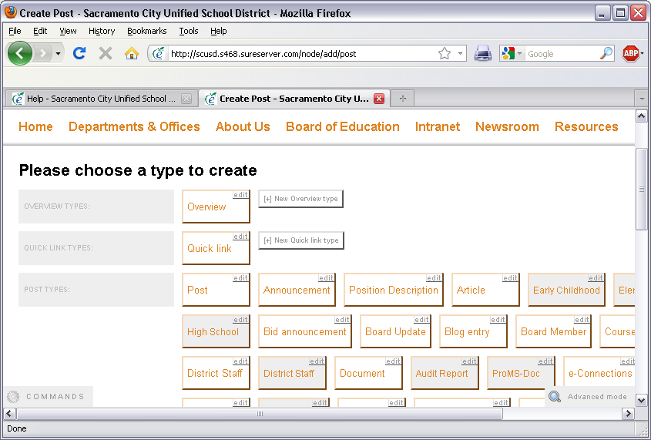
There are many types of posts available. Here’s a description of the most common ones.
- Overview – specialized posts that appear at the top of a landing page above all other content. Used primarily to introduce the information found on the page.
- Quick link – simplified post that when clicked on redirects the user to a link specified.
- Post - Posts are a standard kind of post that appear in the center channel of any landing page.
- Announcement – specialized for announcing an event or new program.
- Article – this post type is used for an article or specific content you want an author listed
- District Staff – specialized post type for district staff contact information
- Document – simplified post type for attaching a document
- Event – post type for an upcoming event
- Form –specialized type for creating webforms
- Pod – Pods is a kind of content used to emphasize other content on the site. It usually displays in the sidebar of a landing page.

Create a post
Method #1: Commands Bar
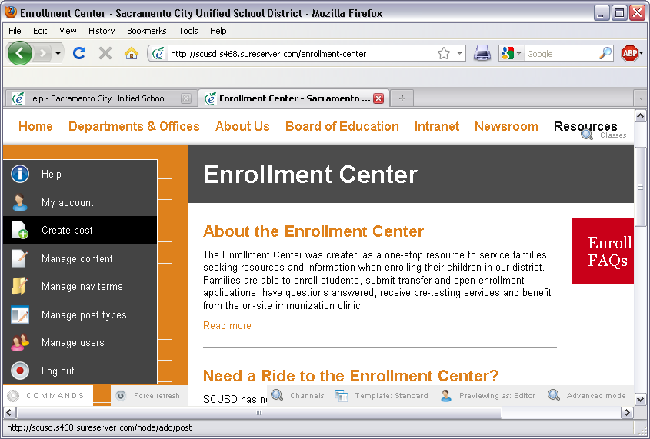
- Click on the commands button in the bottom left and choose Create post.
- Pick the appropriate post type.
- Add content

Method #2: Channels Method
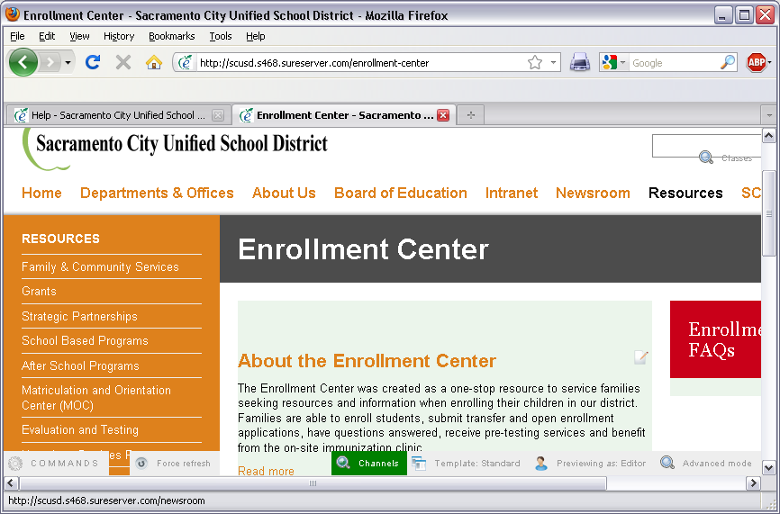
The Channels function allows you to see the areas you can add content directly on the page you are editing. The areas where you can add content will glow a light shade of green. You can create and edit your page overview(s) and posts this way.
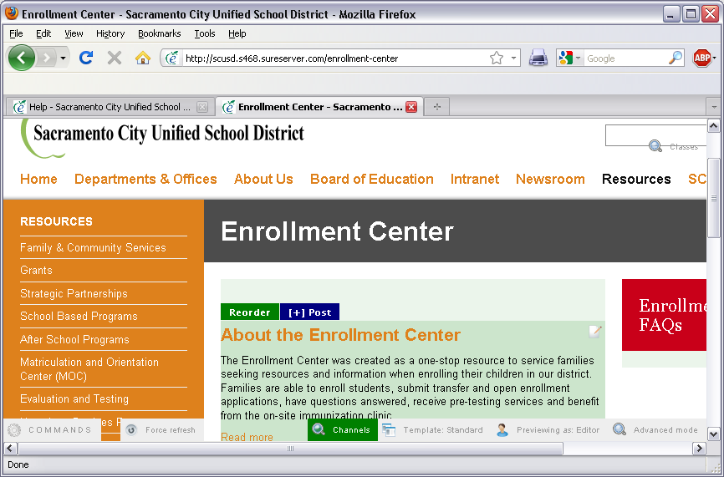
If you hover over the post section, you will see two colored boxes appear. The reorder box allows you to reorder your posts and the [+} post lets you create a new post.
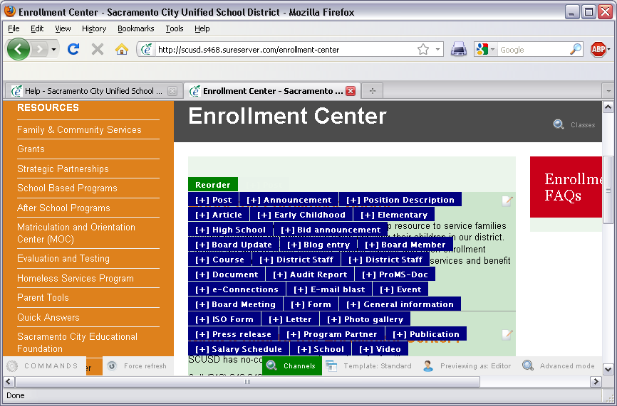

Create a post with the Channels method

Go to the section of the site you want to post content to and click the Channel button (light grey, lower right of screen). If you hover over the very top of the main area you'll see [+] Overview, which will allow you to add an Overview at the top of the page. If you hover just below that (or over the first post in the main channel), you'll see [+] buttons for each type of post you can add. Selecting one of them will bring you to the editing screen.
The great thing about the shortcut version is that your "post type" and Navigation Terms will be pre-populated based upon the section you were in when you started and the post type you chose when hovering.

Post content
- Title: Type in a title. You are limited to 128 characters.
  - Style tip: it's good to keep the title as succinct as possible since you also have a subtitle field to use. A shorter title is easier for users to read when scanning pages.
- Subtitle: Type in a subtitle. (This field is optional.)
- Body: Insert your copy into the body section.
- File attachments: Posts allow you to upload files from your computer into the file attachments field. (This field is optional.)
- Related links: Posts If your post references a another site or document at an external URL, please enter it in this field. Please include a title for each link. (This field is optional.)
- Pick which sections this post will appear: Before you save your post, use the right menu to check the section(s) you want this post to appear in.
- Click save.
- Because you are an administrator, your Post will go live immediately

Formatting tips for all posts
Regardless of the post type you're creating, the Body text area features a Word-like editor to help you format your content. Note that if you paste text (copied from Word, etc), the formatting will be removed so that your content starts out clean.
A few notes that will make using the editor a more pleasant experience:
- Use the drop-down Format box to style your content (the box that says "Normal" in it, by default). All body text should use the "Normal" style, with the exception of section headlines, which should use “Heading 3” for major headings and "Heading 4" for subheads. To follow convention, you should use H3s first, then H4s, then H5s if necessary. The Address format can be used for footnotes. Note that there are Switches under Display Options (more on this, later) that will allow you to display all text tagged as H3s as Tabs at the top of your page, or to create Table of Contents from all H3s. This breaks your content up into smaller chunks or adds links at the top. If you want to take advantage of these display options, be sure to make your main headings within the body H3s while formatting.
- Bold, Italics and Alignment:self explanatory.
- Lists: You can use bullets or numbers to help format lists of information. Bulleted lists are simple: highlight the items you want in your list and click the Bulleted Lists button. To create numbered lists, type your content, highlight everything you want to be included in your numbered list, and click the Numbered List button. If you then want certain subitems in that list to be lettered (second level), highlight just the subitem(s) and click the Indent button to push them in another level.
- Insert Link: You can insert a link to another website, to a page within your site, to an email address or to an anchor in the text (more on this in a bit) using this tool. To insert a link, highlight the text in the body you wish to turn into a link and select the button that looks like a globe with a chain link in front of it. A popup will appear asking for the parameters of the link. You can link to a variety of content, but the most commonly used will be URLs and e-mails. Select the link type from the drop-down, type in the address and click ok to set the link. Note: if you want to link to a post within your site, simply paste or type in a link including everything from the first slash after your URL. For example, instead of http://scusd.s468.sureserver.com/node/55, you would simply add /node/55.
- Remove Link: Click this button to remove the link in the text (highlight the link first).
- Anchors: to add a hyperlink to somewhere within the same post, put your cursor in the spot that will be the destination, or anchor, for the link first. Don't highlight text, just click to put your cursor in the appropriate spot. Click the button that looks like a flag (don't ask us why it looks like a flag but is called an anchor; it's just one of the great mysteries) and name the anchor something brief. Next, highlight the text you would like to become the link to that spot, and click the link icon. In the link type drop-down, choose Link to anchor in the text and then choose the anchor you created in the next drop-down. When someone clicks the link, it will jump them to the anchored part of the page.
- Insert image inline: You can use this button to add an image to your content. Please note that a better / cleaner method is to use the image field, covered later – but if you absolutely have to have an image inline with your text, this is the button to use. Click the image button, then browse server on the next screen. Then you can either choose an image from the file repository, or upload a new one using the "Upload" button. Note: if you're browsing for images you've already uploaded, the folders on your server are on the left. Once you've found the right image, or uploaded a new one, click "ok" on the screen you started with.
- Quotes: Highlight the quote or text, use the Block Quote button to create block quotes within your content.
- Source: Site Admins have the ability to view the HTML source and make edits there, if desired.
- Show Blocks: this is handy when you're formatting content in the editor as it shows where paragraphs break - this is on by default, so turn it off if the formatting is getting annoying. It doesn't affect the actual formatting of your content.
- Remove Format: self explanatory.
- Format dropdown: mentioned above.
- Spell Check / Spell Check as you Type: Note that they are slower than browser-based spell checking, which is available by default in Firefox and Chrome.
- Teaser Break: The Teaser button will insert a break wherever your cursor sits. This is great for controlling how much of your post shows up on overview pages, while allowing the entire post to be viewed when the visitor clicks the title or read more.
Site Admins have the option to make a custom teaser that does NOT show up on the full node, under Display settings (see instructions in the Creating Posts section.)

Create a webform
Forms are used to collect data from site users. Examples include a vehicle donation form, a contact us form, and a submit a request form. Note: forms are not secure and should not be used to collect credit card numbers, social security numbers, or other kinds of secure information.
You can add a form to any existing post.
If you don't have the post started yet, using the form post type create one with a Title and optional body text, and save it. Then edit the post and click the Webform tab to add the form fields.
Adding fields
Each field on the form (for example: First Name, Phone Number, Vegetarian) will need to be added individually, as what is called a "component" of the form. They are all found under the Components button.
- Give your first component a name, for example: First Name
- Choose the field type you'd like to display. For "First Name" we would use a text field, but there are other options, which are covered below.
- Check the box for Mandatory if you want the user to be required to fill in this field.
- Check or uncheck the box for E-mail if you want the results of this field sent via e-mail to the recipient of the form.
- Click the Add button.
- The next page will give you options for the field you've created, including a description that you can present to your users to help them fill out the field properly. Everything on this page is optional, and will change depending upon the type of field you are creating:
  - textfield: Basic textfield type. You'll have options like Label, Description (text that can help your users fill out that field), etc.
  - grid: Allows creation of grid questions, denoted by radio buttons. Options go across the top (for example, Poor, Good Great), and Questions appear on the side (How are we doing?) The display allows the user to fill in bubbles as responses to each question.
  - e-mail: A textfield that automatically fills in a logged-in user's e-mail, or allows anonymous users to add their e-mail manually.
  - file: Allow users to submit files of the configured types. On the configuration screen you are able to determine the types of files that can be uploaded.
  - textarea: A large text area that allows for multiple lines of input. Options include the ability to change the amount of text you'll accept, change the size of the text box, etc.
  - date: Presents month, day, and year fields. Options include format, time zone and available years.
  - hidden: A field which is not visible to the user, but is recorded with the submission. This field requires that you insert tokens (pieces of code that will pull various information from the visitor) and is for advanced users only.
  - time: Presents the user with hour and minute fields. Optional am/pm fields.
  - markup: Displays text as HTML in the form; does not render a field. For advanced users only.
  - pagebreak: Break up a multi-page form.
  - select: Allows creation of checkboxes, radio buttons, or select menus. Options are created on the second page, where you are able to add the items that you want to appear in your select list.
  - fieldset: Fieldsets allow you to organize multiple fields into groups.
Add an Email Address
Once you're done adding the fields you want, click the Emails button at the top of the form. Here you can add (one or more) email addresses for whomever should receive the webform submissions.
Note that the webform submissions will always be available on the site, but it's a good thing to have someone notified when they are submitted, too.
Form Settings
- Confirmation message: You can optionally enter text that the user will see when they complete the form, or –
- Redirect URL: instead of a confirmation, you might send them to a page within your site.
- Submission limit: optionally restrict the number of times someone can submit the form.
- Submission access: optionally restrict what roles can see the form.
- Advanced settings: click the text to expand this link, and choose from the options provided. Note that "show complete form in teaser" will often be a desired choice, so that the user doesn't have to click through from the teaser to another page to fill out the form.
View or Download Results
- Browse to the webform post and select the Results tab. You will see all the most recent submissions displayed under the “submission” sub-tab. You will see date/time, user, IP Address, and two links to View and Delete.
- The system has a built-in analysis function. Select Analysis under Results to view statistics about the submissions of the form.
- Click the Table button to view the results in a table.
- You can download all the results to Microsoft Excel or other spreadsheet program by clicking the Download button and clicking “Save” when prompted. The file will download onto your computer as a CSV file which can opened, edited, and studied.
- The Clear button will clear all of the webform submissions; not suggested unless you're clearing test submissions before your site goes live.

